# NETWORKING & SYSTEM ADMINISTRATION LAB

**Name: Stebin Babu**

**Roll No: 44**

**Batch: B**

**Date: 28/03/2022**

**Experiment No.: 3**

# Aim

Familiarization of the linux commands.

# Procedure

1. **cat -n**

This command is used to specify the contents with line number. Syntax :- $ cat -n filename

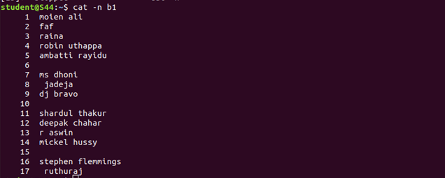Output :-

# cat -b

This command is used to remove the empty lines from the file. Syntax :- $ cat -b filename

Output :-

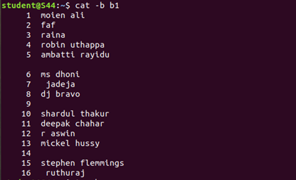

# touch

This command is used to create an empty file. Syntax :- $ touch filename

Output :- A new file will be created.

# echo

This command is used to add contents to the file. Syntax :- $ echo content >> filename

Output :- Contents will be added to the file.

# head

This command is used to display the first 10 lines of the file by default. Syntax :- $ head filename

Output:-



# head -number

This command is used to display the lines of the file to the specified number from

head.

Syntax :- $ head -number filename Output :-

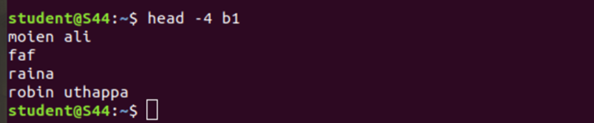

# tail

This command is used to display the last 10 lines of the file by default. Syntax :- $ tail filename

Output :-

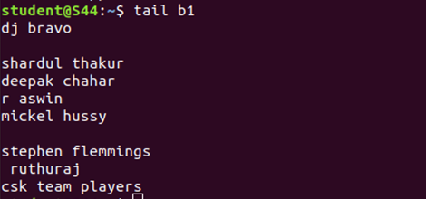

# 24.tail -number

This command is used to display the lines of the file to the specified number from

tail.

Syntax :- $ tail -number filename

Output :-



# 25.cut -d- -f2

This command is used to cut and the display the contents based on the delimiter

given.

Syntax :- $ cut -d- -f2 filename Output :-

